COIS-4000Y

Status Report

Prepared for Hugh Elton

Premdeep B.,

Jason E.,

and Ben Y.

It’s great to have you back, Dean Elton. To catch you up to our current level of progress, here’s a linear ordering of the user interface as it presently stands. The application is not complete yet, the AI being the main component remaining. Any design decisions we had to make on our own will be outlined as they occur. We are still ironing out bugs in the battle system, but once it is completed we will have a fully functional player versus player beta application for you to actually be able to use. Our AI system has been fully planned out and designed, but is designed in a way where we require the game to be fully functional before we can truly implement it. Our beta will be available to you by Monday, the 24th, with or without the AI in place.

We will begin with the main menu. Our tentative title for the application is “Roman Civil War,” but this can be changed to anything you see fit.

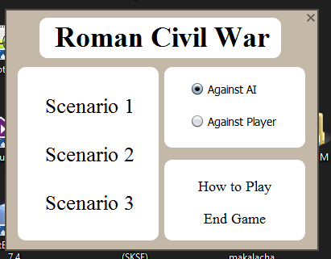

The user is presented with the options we had previously discussed with you, no changes have been made. The scenario buttons can be clicked, to choose a scenario, with the options at the top right determining the opponent (AI is selected by default).

Clicking “How to Play” will present you with the following screen:

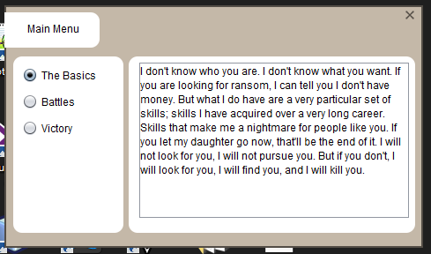

The actual text within the screen has not yet been written, as of now all three options present the user with randomly selected movie quotes (pictured: Liam Neeson’s monologue in the film *Taken*). This is just to give you an idea of how the interface will look.

Selecting a scenario from the main menu will present you with a “team selection” screen:

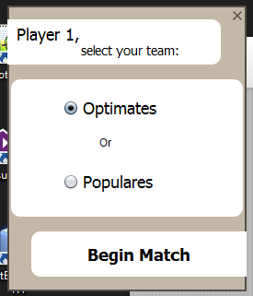

This is to give the player’s the options of which factions within each scenario to fight for. In essence, the player can choose to begin as the red or blue teams, which have their own specified army units, starting positions, and other faction-specific variables. (Our sample scenario used is fought between the Optimates and Populares.)

Once player 1 selects their faction, they will be presented with the map screen:

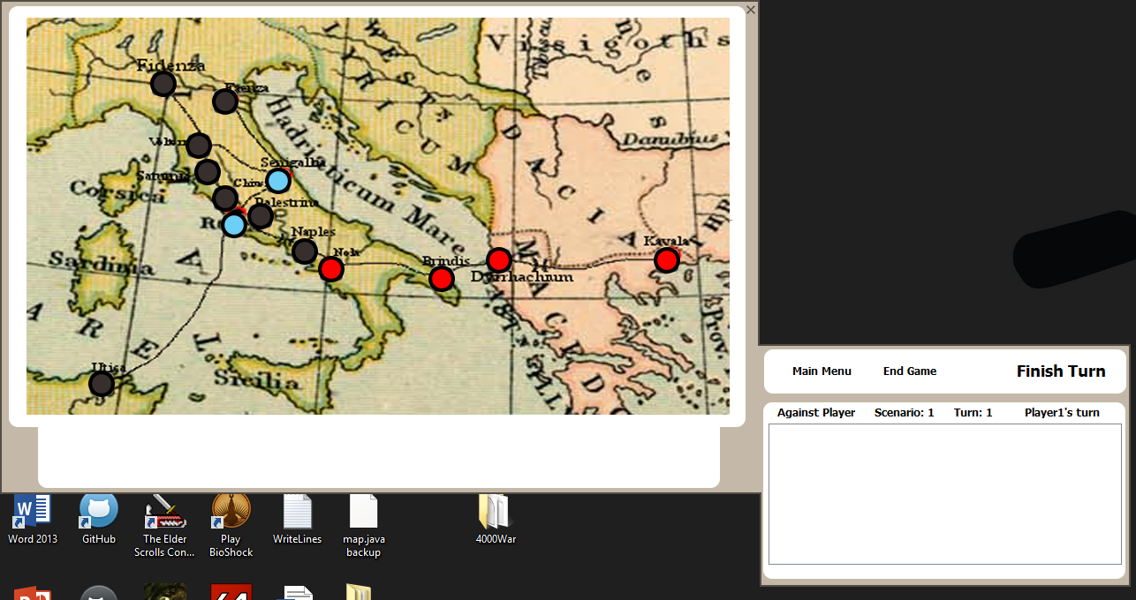

This is actually a combination of two separate windows: one contains the map screen and information specific to each position node, while the second – located at the bottom right of the screen – shows game specific information (such as the turn count, who’s turn it presently is, a list containing all actions that have been made in the current turn, a “finish turn” button, etc). To examine the map screen in greater detail, clicking on a node (the colouration of which is: dark grey for cities, light blue for port towns, beige for checkpoints between cities [albeit none are present in our sample scenario], and red for nodes containing armies controlled by faction 1 and blue for faction 2 [player’s decide their factions in the previous window]). *[Note: checkpoint locations were added as we made the decision to include them and incorporate all movements as single-turn events. Roads that would take multiple turns to travel through would simply have one checkpoint for every turn it would have otherwise taken to travel].*

When a node is clicked, the user will be presented with a popup menu at that location that will contain all options available to them at the node selected (eg, only nodes the user has an army unit on will give them the “movement” option). Information about that node (the city name, node type, armies the user controls there, fog-of-war enemy units known to be there, etc) will be presented below the map (presently only the three shown items are listed, more will be added soon).

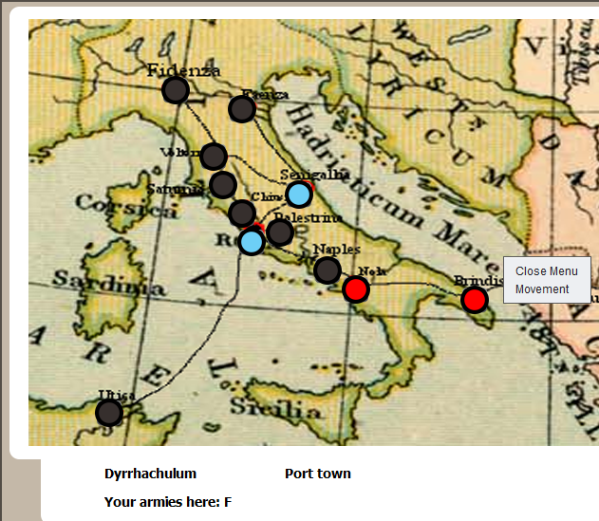

Clicking movement will present the user with which units can be moved (similarily, if “merge” or “divide” are available, once they are clicked, the units available to commit said action will be shown:

“Movement” clicked -> “Fleet” selected -> 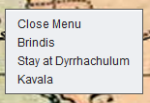

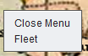

These events will all be added to a list on the side-panel:

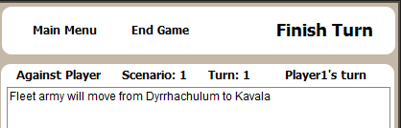

More actions selected:

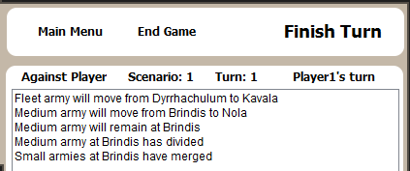

This list, along with any other compromising information presented, is cleared whenever the player commits their actions via clicking the “finish turn” button. The map will also be hidden, and the screen will prompt the next player that it is now their turn:

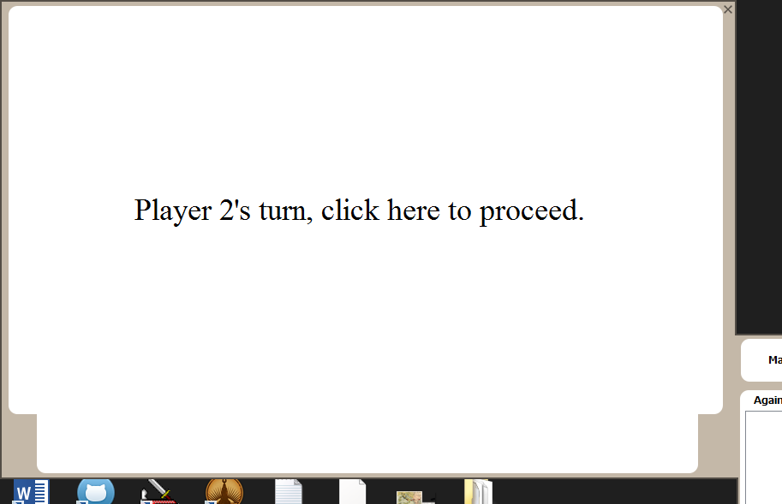

Once the user clicks to continue, they will be presented with all information relevant to them (such as node colouration, etc.).

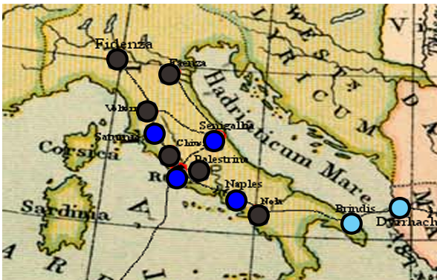

When both player 1 and 2 have “finished” their turns for that round, movements will be executed at the same time (merges and divides will happen instantly when selected). If a battle occurs once a full turn is completed, while the map and all other information is still hidden, the players will be notified by the battle via a prompt. The prompt will ask them if they wish to “commit” the battle, or if they want to attempt to flee:

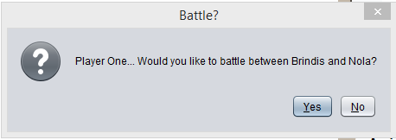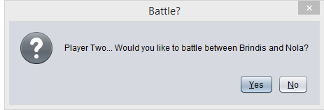

The prompt is presently a yes/no question, but the UI for it has not yet been fully designed and this will be changed, but it will remain a popup-style prompt. The outcome will be declared in a following prompt (we decided this did not have to be hidden between players because both will be knowledgeable of the battle and outcome regardless. Albeit if a player elected to flee and succeeds, it will simply say they fled and not which location their army has fled to – that would be presented on the map for their next turn).

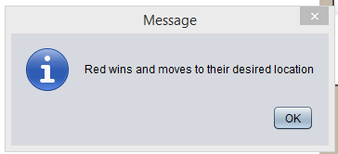

(“Red” and “blue” are our working codenames for each faction)

This concludes the run through of the interface as it presently stands. As previously stated, we are still working on bugs within the battle system, but otherwise the game has almost neared completion; you will be able to test it on the 24th. The learning tool has remained a Java application, meaning it will be a multi-platform desktop application as you had requested. We have kept the learning tool as close to your specifications as possible, and I hope you like what you have now seen of it. We eagerly await your feedback once the beta version has been completed!